**New Services in the Class file**

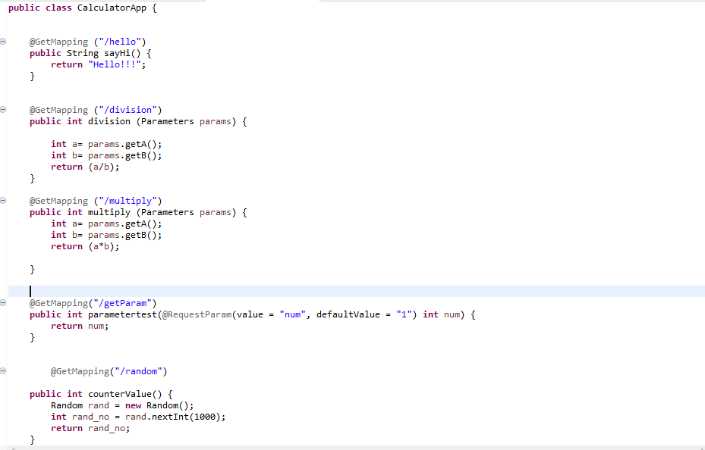

Output :

**Random Number Generation**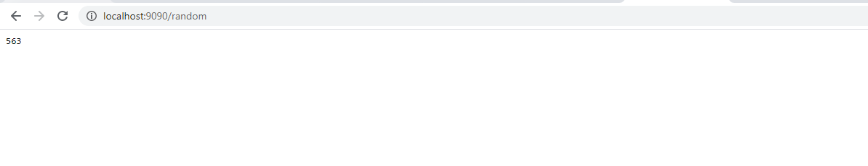

**Service with Parameters-Default**

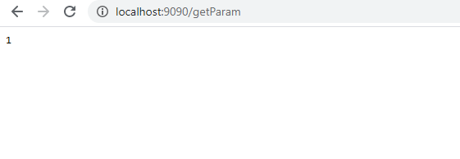

**Service with Parameters-with input**

